Introduction to Swing II.
We are going to put into practice the concepts seen in the previous document.
1. Create a simple window:
Create a new project in netbeans, call it “using Swing”.
Now we will create a new class, clicking with the right mouse button on the project “using Swing”:
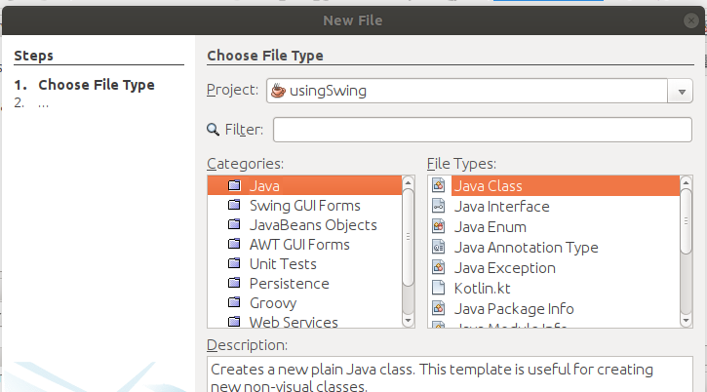
This new class will be called frame1.

We will use this new class to create a window, that is, create a class that extends to Jframe. Write the following code in the frame1.java class:

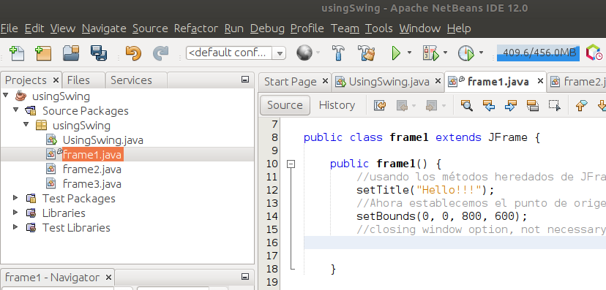

As you can see we created a class that will be a window with title and size.
Now we go to UsingSwing.java, which is the main class of the application (it has a “main” and it is the start of the program execution) and we write:
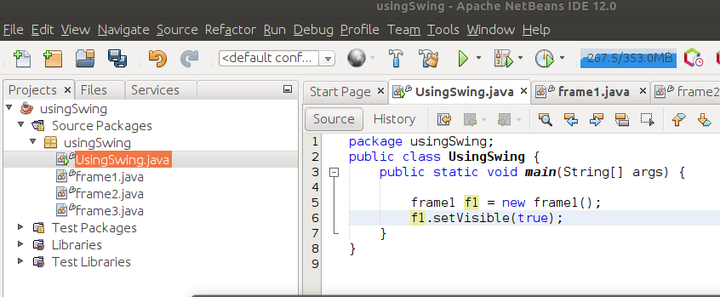

We save everything and execute, it should appear a small window with the title.

This is our first window !!!
Although in reality it does nothing, if we give the icon to close it apparently closes, but in reality it continues to run in a non-visible way. This can be seen from Netbeans in the lower right corner:

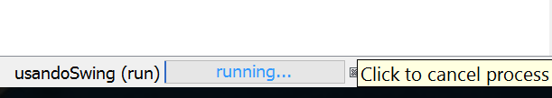
It indicates that the program using Swing is still running, to finally stop it you must click on the X, in fact if we place the mouse pointer over the cross, a message appears “Click to cancel process”.

2. Adding a panel:
To add a panel we can write in our example:
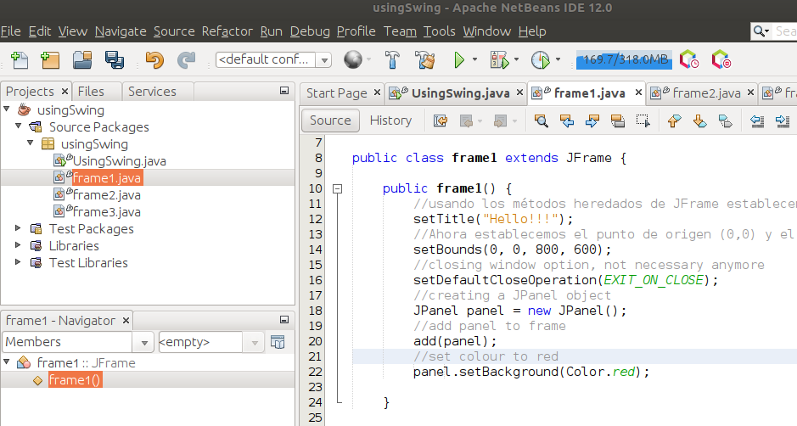

As we see there is an error, Netbeans marks it and if we go over it and click on it, it gives us the solution: an import is missing:
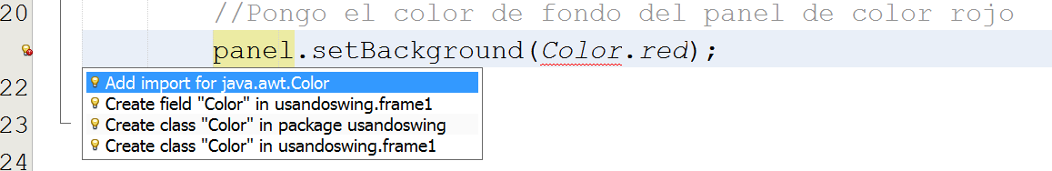
We click on the first option and Netbeans adds the necessary import
The result of the execution will be:
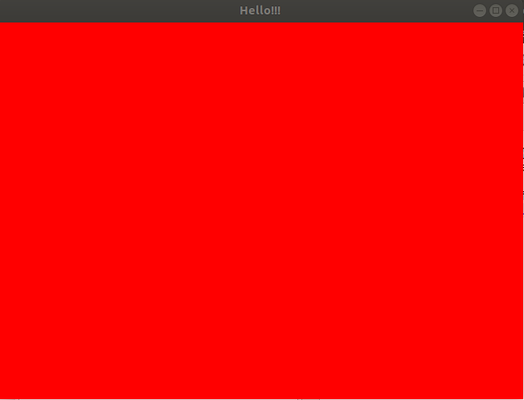
3. Buttons:
We are going to create a new java class to our project, we will call it frame2. In it we are going to create a class with a button:

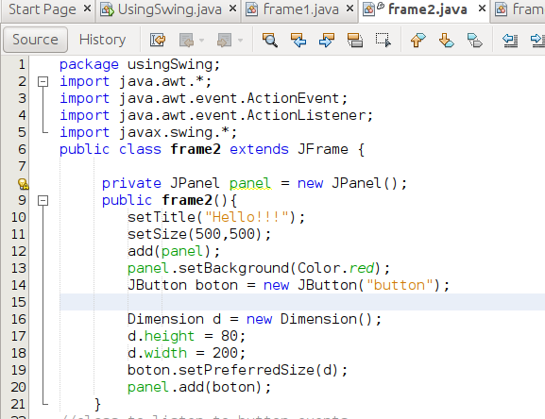

Now we will make this window appear from the class Using Swing.java:
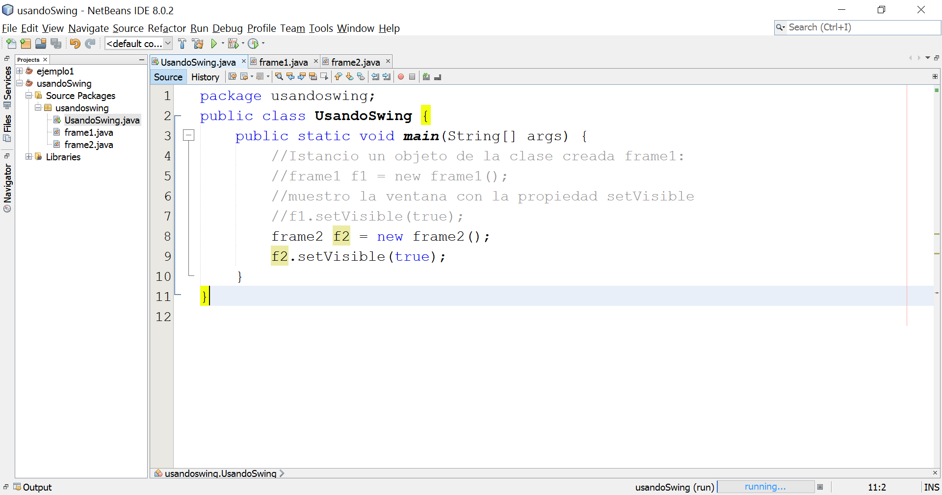
If we execute:

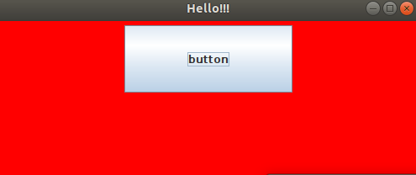

If we click on the button nothing happens, that is because we have not yet added a listener to handle the button click event. For this you have to modify frame2.java and leave it like this:

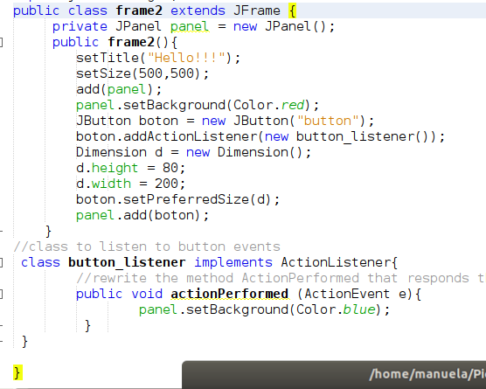

Now we will have a button that if we click it changes the color of the panel to blue.
4. Layouts.
For the layouts example we will create a class called frame3.java:

The complete code of frame3.java:
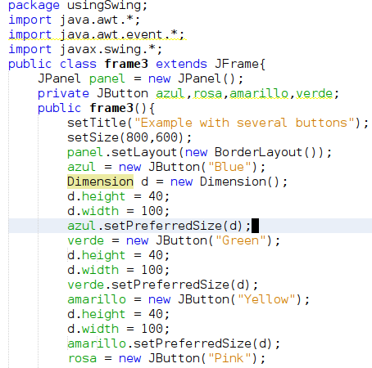
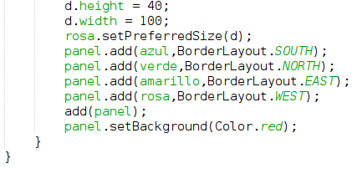

In order to use this new frame, we change UsingSwing.java:

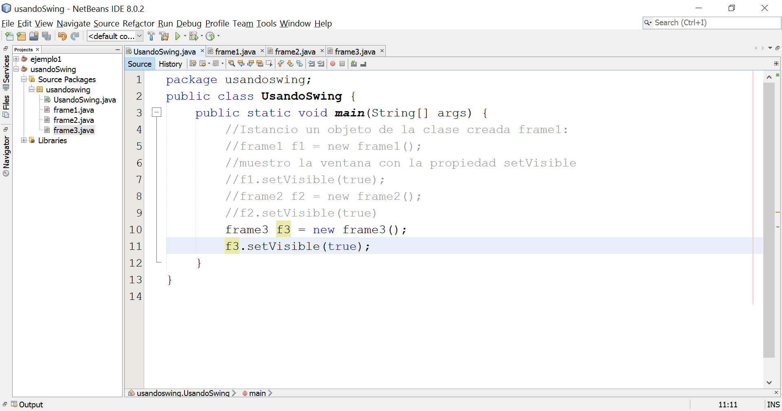
If we execute:

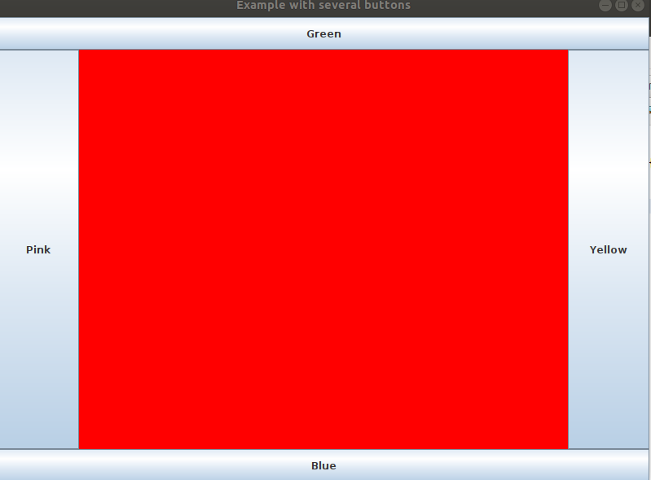

Now you will need to write the code to actually change the colours.

